

# CMR INSTITUTE OF TECHNOLOGY SET-1

Kandlakoya (V), Medchal Road, Hyderabad-501401

.

Assignment-2

A.Y : 2022-23

1. Explain Partial order Relation. Draw the Hasse Diagram for the Poset (P(S), /) , where S=factors of 36.
2. i)What is the coefficient of x122 y78 in the expansion of (2x-y)200 ?

ii)Define sum rule and product rule

1. Find n if
2. P (n, 2) =72 ii) P(n,4)=42 P(n,2) iii) 2P (n, 2) +50= P (2n, 2)
3. Explain planar graph,complete ,bipartite graph,,sub graph and complete graph with examples
4. a)Define DFS algorithm and mention the steps followed in defining algorithm.

b)Solve the following example using Breadth first search algorithm .

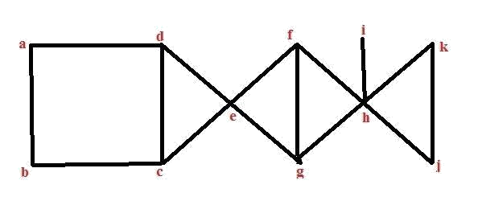

CMR INSTITUTE OF TECHNOLOGY SET-2

Kandlakoya (V), Medchal Road, Hyderabad-501401

Assignment-2

A.Y : 2022-23

1. Explain about the properties of binary relations with examples
2. i)Find the term which contains x11 and y4 in the expansion of (2x3-3xy2+z2)6

ii)Find the number of three digit even numbers with no repeated digits

1. i)How many solutions are there to the equation x1+x2+x3+x4+x5=16 where each xi>=2

ii)In how many different ways can a committee of 5 teachers and four students be selected from 9 teachers and 15 students

1. .Find the chromatic number for the following graph

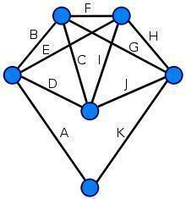

1. Explain about isomorphism and Verify whether the following two graphs are isomorphic or not.

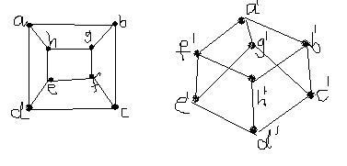

# CMR INSTITUTE OF TECHNOLOGY SET-3



Kandlakoya (V), Medchal Road, Hyderabad-501401

Assignment-2

A.Y : 2022-23

1. Let *n* be a positive integer and *Sn* be the set of all divisors of *n* If *n* = 30,

*S*30 = *{*1*,2,* 3*,* 5*,* 6*,* 10*,* 15*,* 30*}*?check whether the given hasse diagram is lattice or not

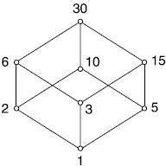

1. i) Among 20 members of a team,there are 2 wicket keepers and 5 bowlers . In how many ways can eleven persons can be chosen to include only one wicket keeper and atleast 3 bowlers.?

ii)Suppose there are many red socks,many white socks and many blue socks in a box what is the least number of socks that one should take out from the box to be sure of getting a matching pair?

1. a)How many arrangements are there for the words **`MISSISSIPPI**`?

b) How many arrangements are there for the words ‘**TALLAHASSEE** so that no two A’s should be adjacent?

1. i) Prove Handshaking Lemma with example

ii)Show that if a planar graph is Self dual then |E|=2|V|-2

1. Show that the following graph is not Hamiltonian.

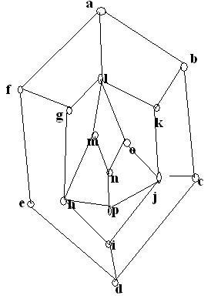

# CMR INSTITUTE OF TECHNOLOGY SET-4

Kandlakoya (V), Medchal Road, Hyderabad-501401

Assignment-2

A.Y : 2022-23

1. Let *f*(*x*) = *x* + 2, *g*(*x*) = *x −* 2 and *h*(*x*) = 3*x* for *x* *R*, where *R* is the set of real numbers. Find *g ◦ f*; *f ◦ g*; *f ◦ f*; *g ◦ g*; *f ◦ h*; *h ◦ g*; *h ◦ f* and *f ◦ h ◦ g*.
2. i) How many bit strings of length 8 either start with bit 1 or end with two bit 00?

ii) How many bit strings of length 8 either start with bit 11 or end with two bit 11?

1. Explain pigeon hole principle with example
2. Illustrate the concept of adjacency matix representation for the following example

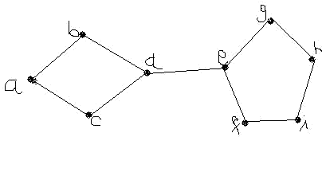

1. i)Construct Euler’s circuit for the following graph

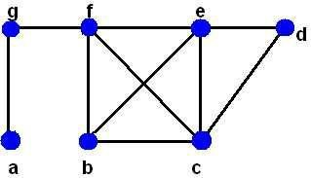

ii)Define about walk,trail,path,cicuit,cycle?